

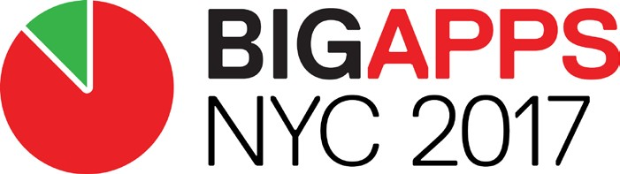
What did you see?

Start with Observations: Observations are facts.
They are the “what” behind our research. They represent what you saw, what you heard, and what you observed during the research phase.
Answer the questions below:
2 . 2 1 . 2 0 1 7

WHAT DID YOU
OBSERVE?

We saw there are some smart pillows and sleep trackers to solve different problems during sleep, for example, Anti-snore pillow, ZEEQ smart pillow, iComfort smart support hybrid queen pillow, Memory foam pillow, Fitbit, Beddit and etc. Some solutions focus on sleep quality improvement, and some solutions try to solve snore during sleep.
We saw the interviewees are interested in the smart pillow and they are eager to solve problems during their sleep.

What did you learn in your interview and research process?

We found that in order to determine the problem we wanted to solve, we need ask interviewees to answer open ended questions. we can understand what problems users have and find common problems. Through interview and research process, we can dig deeper into the subject that we are researching and refine our idea which makes our research easier to set up. And with review and research, we can find the significance of our idea.

What surprised you during your research?

There are current solutions satisfy part of the demands from consumers, but interviewees want to solve all problems in one solution. People think our smart pillow solution need not only provide heart rate and blood pressure detect during sleep, but also provide music to make them sleep quickly, and make them feel cool in summer and warm in winter. And people think the price of our smart pillow can not be higher than other similar products although they want our smart pillow is multi-functional.

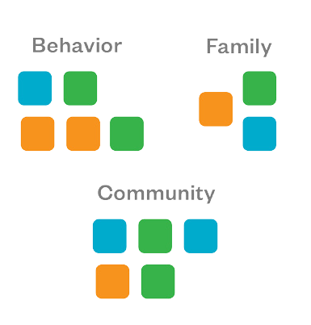
Synthesis is about pattern recognition. We will cluster our research into patterns again and again as we make sense of our data.
2 . 2 1 . 2 0 1 7

PATTERNS

life style
price
convenience
What has been consistent across your research (interviews, observations, secondary research, primary research)?
According to interviews, observation and research, we find sudden death detection during sleep is an important question. Sudden adult death syndrome is a sudden unexpected death of adolescents and adults during sleep. The main cause of sudden death during sleep is heart arrest (CA), and it’s difficult to detect without professional equipment. We can monitor heart rate and blood pressure to detect cardiac arrest in sleeping. As aging society and high sudden death rate, our idea, smart pillow, would have a good market.
What are the 3 commonalities you have learned about the user group you’re researching?
The price of a smart pillow can be reasonable.
Users have some problems during sleep.
Users need a smart pillow to monitor heart rate and blood pressure during sleep.

If you could synthesize the above questions into 5-6 “buckets,” what would they be?
Start simple! It’s OK to have a bucket that says “family” or “transportation”. We’ll get more specific later.
sleep problems
family

health

Who is the user? Think about the user in the context of your research and the problem you
are solving. This will help keep our solutions human-centered.

We cardiovascular patients need a product can precisely track heart rate and blood pressure during sleep. It's very dangerous for us in sleep, because no one knows if we are in case of emergency. Regular smart bands like Fitbit or smart watch like Apple Watch in current market are not that accurate in medical applications at all. Besides that, they are not comfortable in sleep at all. You won't wear them in bed.
What did this user
(user quote)
Memorable name:
J.S. Li, W.P. Zhu, L. Willard, D. Yoria, F. Daniel, K. Cui

Draw the user

For a cardiovascular patients, he has to measure his heart rate and blood pressure at fixed periods to know if his health condition is normal. If his heart rate or blood pressure is abnormal, he may have to be in hospital until his condition is good enough to live away from special care unit.
What does this user

To precisely track cardiovascular patient's health condition in sleep. To ask for help when cardiac arrest happens in sleep.
Motivations

Comfortable Precise Reliable
Needs

To track heart rate and blood rate precisely. Not to impact sleep.
Challenges
2 . 2 1 . 2 0 1 7

USER PERSONA

He wants to get something can track his condition accurately and ask for help when emergency happens in sleep. The smart health product he needs should be the mixture of a monitor and a guard in sleep. This product must be comfortable enough to not impact his sleep. And it would better make him not feel it existing at all when he falls sleep.
What does this user

If something like that less than $1,000 really launches, he would buy it.
What does this user

2 . 2 1 . 2 0 1 7

 INSIGHTS

An insight reveals the or the underlying user need.
An insight is a statement about people’s
and that highlights needs or areas to be improved.
An insight represents an It points to an area that needs improvement.
Reveals an “Aha”: Once you state it, it and simplifies your research.
Is a Solution: While it inspires many ideas, it doesn’t point to a single one.

Aging society, lots of seniors live lonely. This factor adds risk for sudden death.
or
that informs insight...
Interviewee A needs a method or product to monitor his parents’ body status.
(user) (unmet need)

because his parents are more than 70 years old and they don’t live with interviewee A.

Insight: because of the improvement of medical condition, it’s now in the aging society. Lots of seniors need special help.

Practice again...

Work pressure disrupts biological clock, reduce the sleep quality.
or
that informs insight...
Interviewee B needs to know about his sleep status. Because

he finds himself difficult to enter deep sleep recently, and he needs

specific data to show his sleep quality.

Insight: many people want to improve their sleep quality.


DESIGN CHALLENGE OVERVIEW


Transportation


Knowledge

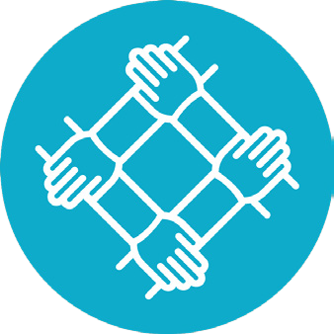
Community Resiliency

Overview This challenge is focused on how to increase ease of use and access to transit and expand travel options for New York City youth, seniors, and immigrants. Through various listening sessions this past fall, we consistently heard from constitu- ents about the difficulty of navigating the City’s transportation network in order to access jobs, education, social services, and other opportunities. How might we use data and technology to make transit easier to use and develop innovative alternatives to supplement existing transit infrastructure?

Overview This challenge is focused on providing New York City youth, seniors, and immigrants with better access to
information in order to make more informed decisions for their daily lives (i.e. at home,
at work, at school, in public). Having access to accurate, timely, and user-friendly information is critical to being able to make independent choices, and proactively address one’s own needs. How might we use data and technology to improve access to information to ensure New York City youth, seniors, and immigrants can make informed decisions and take action in their daily lives?

Overview This challenge is focused on building strong, resilient communities by fostering more inclusion and connection for New York City youth, seniors, and immigrants where they live, learn, work, and play. Creating opportunities for these constituencies to be included and
physically and socially connected results in stronger, deeper support networks, which are critical to building resilient communities for all. How then might we use data and technology to create opportunities for New York City youth, seniors, and immigrants
to feel included and socially and physically connected in their daily lives?

The following pain points were themes that emerged in our listening sessions with youth, seniors, and immigrants and the social practitioners and city organizations that serve them:

- Mobility constraints
- Language barriers
- Cost of transportation
- Lack of access to timely information
- Technology barriers
- Navigating multi-modal transit

The following pain points were themes that emerged in our listening sessions with youth, seniors, and immigrants and the social practitioners and city organizations that serve them:

- Lack of access to updated information
- Navigating resources
- Coordination amongst service providers
- Lack of educational opportunities
- Technology barriers related to ease of use and training
- Data literacy
- Language barriers

The following pain points were themes that emerged in our listening sessions with youth, seniors, and immigrants and the social practitioners and city organizations that serve them:

- Economic instability
- Lack of local support system
- Feelings of isolation
- Difficulty engaging with government
- Cultural assimilation
- Language barriers

